Kubernetes Task
Task Description:
Setup minikube at your local and explore creating namespaces (Go through official documentation).
Before installing minikube install docker.
sudo apt update
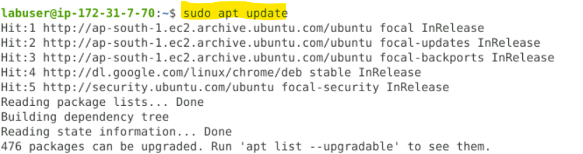

sudo apt install -y docker.io
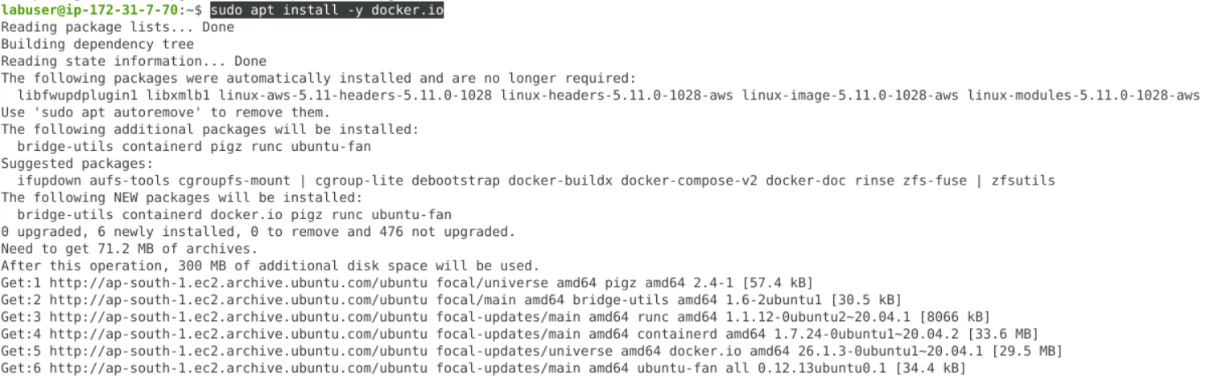

sudo systemctl start docker
sudo systemctl enable docker
sudo docker version
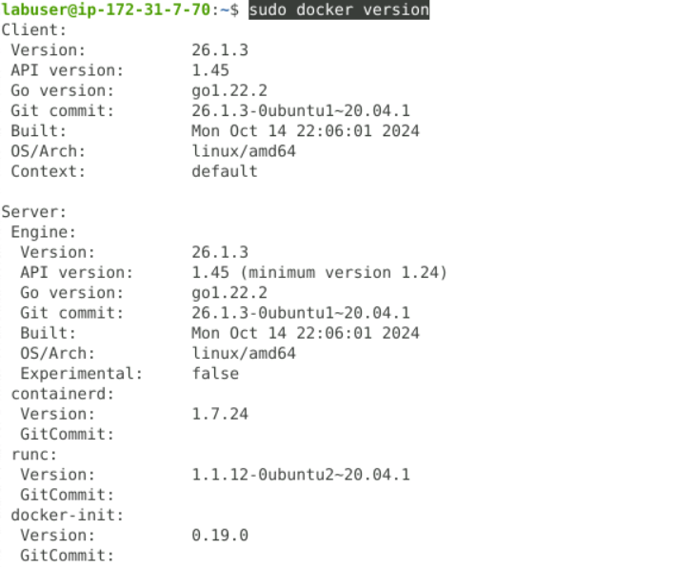

curl -LO https://storage.googleapis.com/minikube/releases/latest/minikube-linux-amd64
Install minikube in the linux server
sudo install minikube-linux-amd64 /usr/local/bin/minikube
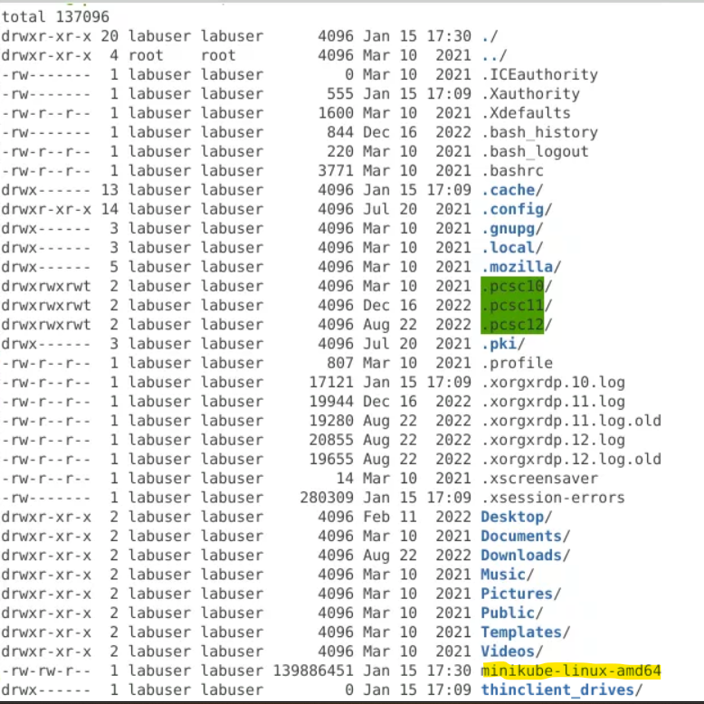

Check minikube version
minikube version
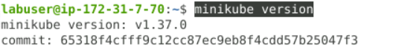

Add permission to the “labuser” so Minikube can use the Docker driver.( /var/run/docker.sock)

Add user(labuser) to the Docker group
sudo usermod -aG docker labuser
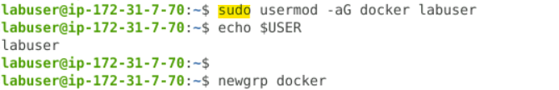

Reload group membership
newgrp docker

Verify Docker access (no sudo)

minikube start --driver=docker
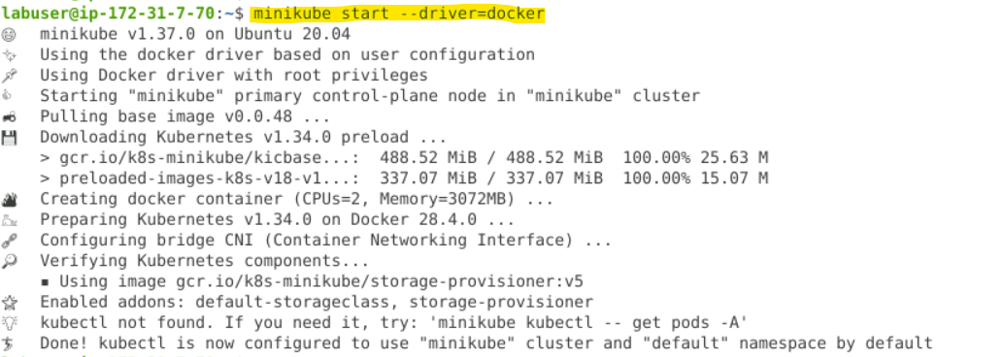

Check minikube status
minikube status
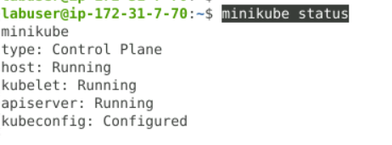

Install kubectl in linux

curl -LO https://dl.k8s.io/release/$(curl -Ls https://dl.k8s.io/release/stable.txt)/bin/linux/amd64/kubectl
chmod +x kubectl
sudo mv kubectl /usr/local/bin/

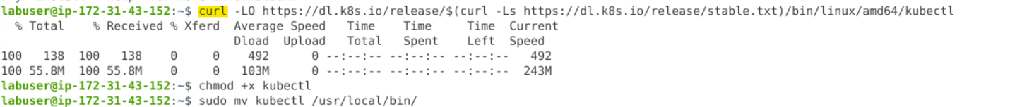

To check the version of kubectl
kubectl version --client
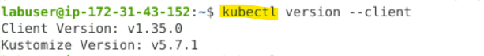

Below are already created namespace by k8s.
kubectl get ns
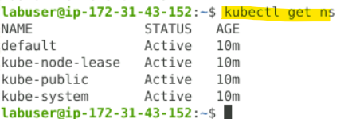

Create namespace.
kubectl create namespace my-namespace
kubectl get ns
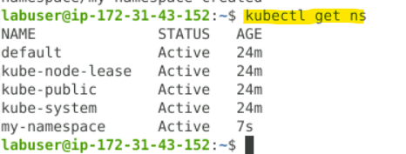

To modify the context
kubectl config set-context --current --namespace=my-namespace
Create deployment
Two pods deployed as per mentioned in the yaml file.
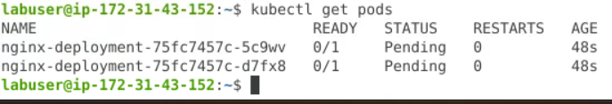

Change namespace to “default”.
kubectl config set-context --current --namespace=default
No pods were there in the “default” namespace.
kubectl get pods -n default

In “my-namespace” namespace 2 pods are deployed.
kubectl get pods -n my-namespace
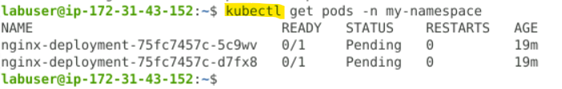

Deployment namespace
